
ASSIGNMENT 6: IMPLEMENTATION OF DATA INTEGRITY CONSTRAINTS
DATABASE MANAGEMENT SYSTEM
ALLIANCE UNIVERSITY
Department of Computer Applications
SUBMITTED BY: RUPESH RL
REGISTER NO: 2511021240035
COURSE: BCA
YEAR: 2ND YEAR
PROJECT NAME: Courier and Parcel Delivery Management System

1. Aim
To apply integrity constraints (primary key, foreign key, UNIQUE, CHECK and DEFAULT) on the tables of the courier database, to explain why they are used, and to run SQL statements that show the data and relationships are protected.

2. What is Data Integrity
Data integrity means the data in the database is correct and consistent. The database does not know by itself that a parcel weight cannot be negative or that a parcel must belong to a real customer. We give these rules as constraints, and the database checks them every time data is inserted, updated or deleted. If a statement breaks a rule, it is rejected.
Constraint | What it does
PRIMARY KEY | Identifies each row uniquely. It cannot be NULL and cannot repeat.
FOREIGN KEY | A value in a child table must exist in the parent table. It keeps the relationships correct (referential integrity).
UNIQUE | The value cannot repeat in the column, but NULL is allowed.
CHECK | The value must satisfy a condition that we write.
DEFAULT | Gives a value automatically when none is supplied.
NOT NULL | The column must always have a value.

3. Primary Keys
The primary keys were already created in Assignment 5. Every table has one integer ID as its primary key.
Table | Primary key | Why
Customer | CustomerID | Identifies one row of Customer
Branch | BranchID | Identifies one row of Branch
Employee | EmployeeID | Identifies one row of Employee
Vehicle | VehicleID | Identifies one row of Vehicle
Receiver | ReceiverID | Identifies one row of Receiver
Parcel | ParcelID | Identifies one row of Parcel
Delivery_Assignment | AssignmentID | Identifies one row of Delivery_Assignment
Parcel_Tracking | TrackingID | Identifies one row of Parcel_Tracking
Payment | PaymentID | Identifies one row of Payment
Complaint | ComplaintID | Identifies one row of Complaint

4. Foreign Keys
The foreign keys were also created in Assignment 5. This table lists all of them. RESTRICT means the parent row cannot be deleted while child rows exist. CASCADE on update means a changed parent ID is also changed in the child rows.
Constraint | Child column | Parent column | On delete | On update
fk_employee_branch | Employee.BranchID | Branch.BranchID | RESTRICT | CASCADE
fk_vehicle_branch | Vehicle.BranchID | Branch.BranchID | RESTRICT | CASCADE
fk_parcel_customer | Parcel.CustomerID | Customer.CustomerID | RESTRICT | CASCADE
fk_parcel_receiver | Parcel.ReceiverID | Receiver.ReceiverID | RESTRICT | CASCADE
fk_parcel_bookbranch | Parcel.BookingBranchID | Branch.BranchID | RESTRICT | CASCADE
fk_parcel_destbranch | Parcel.DestinationBranchID | Branch.BranchID | RESTRICT | CASCADE
fk_assign_parcel | Delivery_Assignment.ParcelID | Parcel.ParcelID | RESTRICT | CASCADE
fk_assign_employee | Delivery_Assignment.EmployeeID | Employee.EmployeeID | RESTRICT | CASCADE
fk_assign_vehicle | Delivery_Assignment.VehicleID | Vehicle.VehicleID | RESTRICT | CASCADE
fk_tracking_parcel | Parcel_Tracking.ParcelID | Parcel.ParcelID | CASCADE | CASCADE
fk_payment_parcel | Payment.ParcelID | Parcel.ParcelID | RESTRICT | CASCADE
fk_complaint_parcel | Complaint.ParcelID | Parcel.ParcelID | RESTRICT | CASCADE

Purpose: a parcel cannot be saved for a customer, receiver or branch that does not exist, and a customer, branch, employee or vehicle cannot be deleted while parcels or assignments still use it.

5. UNIQUE Constraints
UNIQUE constraints are added with ALTER TABLE.
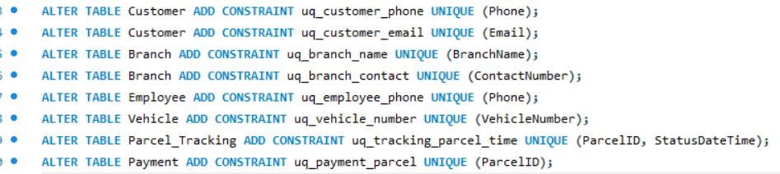
Output:
Table | Constraint | Column(s) | Purpose
Customer | uq_customer_phone | Phone | No two customers can have the same phone number.
Customer | uq_customer_email | Email | No two customers can share an email. Email is optional, so NULL is allowed.
Branch | uq_branch_name | BranchName | Two branches cannot have the same name.
Branch | uq_branch_contact | ContactNumber | Two branches cannot have the same contact number.
Employee | uq_employee_phone | Phone | Two employees cannot have the same phone number.
Vehicle | uq_vehicle_number | VehicleNumber | The same registration number cannot be stored for two vehicles.
Parcel_Tracking | uq_tracking_parcel_time | ParcelID, StatusDateTime | A parcel cannot have two tracking updates with the same date and time.
Payment | uq_payment_parcel | ParcelID | Each parcel can have only one payment row. This makes the Parcel to Payment relationship one-to-one.

6. CHECK Constraints
CHECK constraints limit the values that can go in a column. MySQL checks them from version 8.0.16.
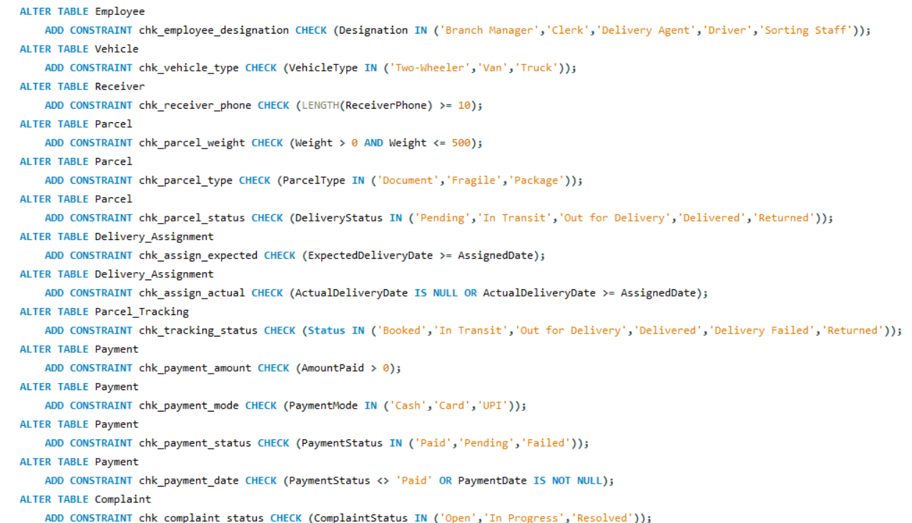
Output:
Query OK, 0 rows affected (for each of the 16 statements)
Table | Constraint | Purpose
Customer | chk_customer_phone | Phone number must have at least 10 characters.
Branch | chk_branch_contact | Contact number must have at least 10 characters.
Employee | chk_employee_designation | Only the roles used in the company can be entered.
Vehicle | chk_vehicle_type | Vehicle type must be Two-Wheeler, Van or Truck.
Receiver | chk_receiver_phone | Receiver phone number must have at least 10 characters.
Parcel | chk_parcel_weight | Weight must be more than 0 and at most 500 kg.
Parcel | chk_parcel_type | Parcel type must be Document, Fragile or Package.
Parcel | chk_parcel_status | Delivery status can only be one of the five allowed values.
Delivery_Assignment | chk_assign_expected | Expected delivery date cannot be before the assigned date.
Delivery_Assignment | chk_assign_actual | If the actual delivery date is filled, it cannot be before the assigned date. It stays NULL until the parcel is delivered.
Parcel_Tracking | chk_tracking_status | Tracking status can only be one of the allowed values.
Payment | chk_payment_amount | Amount paid must be more than 0.
Payment | chk_payment_mode | Payment mode must be Cash, Card or UPI. NULL is allowed while the payment is still pending.
Payment | chk_payment_status | Payment status must be Paid, Pending or Failed.
Payment | chk_payment_date | If the status is Paid, the payment date must be filled.
Complaint | chk_complaint_status | Complaint status must be Open, In Progress or Resolved.

7. DEFAULT Constraints
DEFAULT values are set with ALTER TABLE ... MODIFY. In MODIFY the data type and NOT NULL must be written again, or they will be lost.
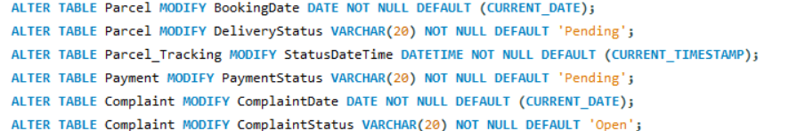
Output:
Table | Column | Default value | Purpose
Parcel | BookingDate | CURRENT_DATE | If the date is not given, today's date is used.
Parcel | DeliveryStatus | 'Pending' | A new parcel starts as Pending.
Parcel_Tracking | StatusDateTime | CURRENT_TIMESTAMP | The tracking entry gets the current date and time automatically.
Payment | PaymentStatus | 'Pending' | A new payment is Pending until it is paid.
Complaint | ComplaintDate | CURRENT_DATE | The complaint gets today's date automatically.
Complaint | ComplaintStatus | 'Open' | A new complaint starts as Open.

Summary of constraints in the database

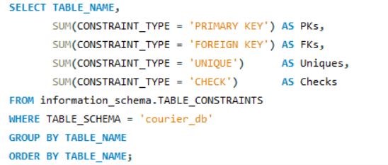
Output:
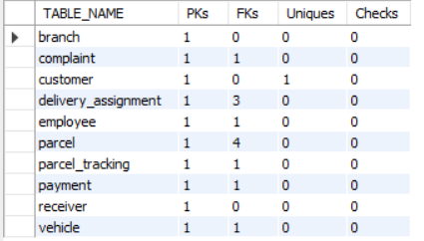
In total there are 10 primary keys, 12 foreign keys, 8 unique constraints and 16 check constraints, along with the NOT NULL and DEFAULT rules.

8. Testing the Constraints
To check that the constraints really work, I inserted a few test rows and then tried to break each rule. All of this was done inside a transaction and I used ROLLBACK at the end, so no test row stays in the database and Assignment 7 starts with empty tables. A statement that breaks a rule is rejected by MySQL with an error, which shows the rule is working.

8.1 Test rows

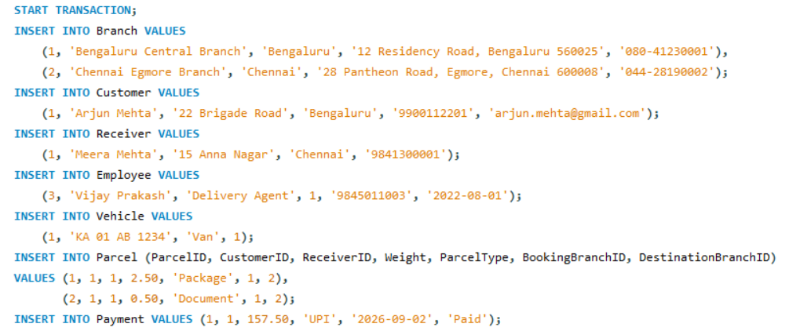
The two Parcel rows were inserted without BookingDate and DeliveryStatus, so the DEFAULT values are used. Let me check that.
Output:

DeliveryStatus became Pending, and BookedToday = 1 means that BookingDate got the current date automatically.
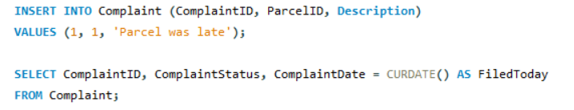
Output:

The complaint status is Open and the date is today. DEFAULT works.

8.2 Tests that must fail

Test 1: Primary key: duplicate CustomerID
Output:
CustomerID 1 already exists, so the primary key stops the second row.

Test 2: NOT NULL: customer without a name
Output:
Name is NOT NULL, so a row without a name is rejected.

Test 3: UNIQUE: same phone number for two customers
Output:
The phone number already belongs to Arjun Mehta.

Test 4: UNIQUE: second payment for the same parcel
Output:
Parcel 1 already has a payment, so the one-to-one rule is protected.

Test 5: FOREIGN KEY: parcel for a customer that does not exist
Output:
There is no customer 99 in the Customer table.
The customer is used by parcels, so ON DELETE RESTRICT stops the delete.

Test 6: CHECK: negative parcel weight
Output:
Weight must be more than 0.

Test 7: CHECK: invalid delivery status
Output:
Lost is not one of the allowed statuses.

Test 8: CHECK: expected date before the assigned date

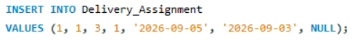
Output:
A parcel cannot be expected to be delivered before it is assigned.

Test 9: CHECK: a Paid payment without a payment date
Output:
If the status is Paid, a date is needed.

8.3 Tests that must work

Test 10: relationships are working

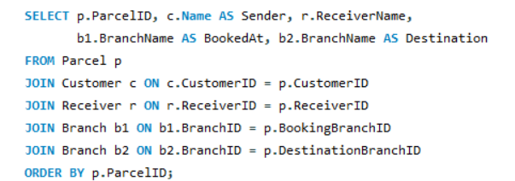
Each parcel is connected to its sender, receiver, booking branch and destination branch through the foreign keys, so the joins give correct results.

Test 11: ON DELETE CASCADE on tracking
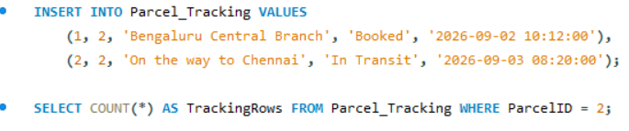
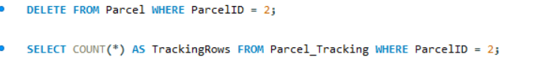
Parcel 2 had two tracking rows. When the parcel was deleted, its tracking rows were deleted automatically. Parcel 2 had no assignment or payment, so the delete was allowed.

Cleaning up

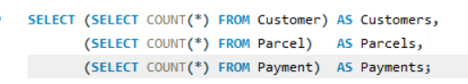
Output:
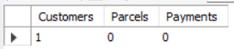
After the rollback all the tables are empty again.

9. Result
Primary keys, foreign keys, UNIQUE, CHECK, DEFAULT and NOT NULL constraints were applied on the ten tables. In the tests, all the wrong data was rejected and the correct data was accepted.

10. Conclusion
Constraints protect the database from wrong data. The tests showed that duplicate keys, a duplicate phone number, a second payment for one parcel, a parcel for a customer that does not exist, deleting a parent row that is in use, a negative weight, a wrong status and wrong dates are all rejected by MySQL. Correct data goes in normally and the DEFAULT values are filled in by themselves. So the data and the relationships between the tables stay correct.

